

**EE 324L Microcontroller and Interfacing Lab**

Project Proposal

Remote Controlled Hospital Bed

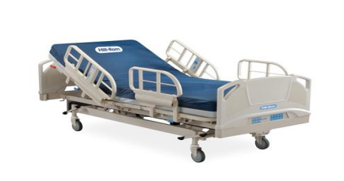

|  |  |
| --- | --- |
| Group Members | |
| Name | **Roll #** |
| Aleem Malik | 23100179 |
| Muhammad Murtaza Hassan | 23100252 |
| Shahzaib Hasnain | 23100297 |

|  |  |  |  |
| --- | --- | --- | --- |
| Section | Table of Contents | | Page # |
| 1 | Project Problem Statement | 2 | |
| 2 | Introduction | 2 | |
| 3 | Plan of Action | 3 | |
| 4 | List of Required Materials | 4 | |

**Project Problem Statement**

Handicapped patients face problems when having to reach for their bed remote and adjust their bed position themselves. They have to rely on external help and if no external help is available, there is nothing they can do.

**Introduction**

In my personal experience I have seen handicapped patients who are confined to their beds and do not have the requisite strength in their hands and body to physically move themselves to adjust their position, reach for the bed remote and then press the remote buttons.

The focus of the project would be to make a remote-controlled hospital bed which would be controlled via a phone connected to the bed via Bluetooth. The user could raise and lower the headboard and the leg portion of the bed as well as drive the bed itself using the phone. As the phone would have a touch screen, no physical buttons would need to be pressed and no extra exertion would be required from the user.

We hope to empower handicapped patients, making them more self-sufficient so that they do not have to rely on external help for their mobility.

**Plan of Action**

In this project we will use an electric patient bed to control the motion of its axes by a modified remote-control unit, it added to the basic control unit on the bed. The control unit that receives a command of motion via Bluetooth, then sends to receive the signal from Bluetooth and analyze it, then sends control signals to a relay to control the motors.

In this project the PIC microcontroller will be programmed to communicate with the Bluetooth and give the connection commands, then it receives the data from the Wi-Fi shield. Then it analyses the data and sends the orders to the controller of the electric bed to actuate the motors.

The bed is moved by using a DC motor controlled by a microcontroller. Every time the up/down button is pressed, the microcontroller directs the DC motor to move the bed to reach 10 degree and is set for maximum 60 degree.

Here are the block diagrams of the Hospital bed control system:



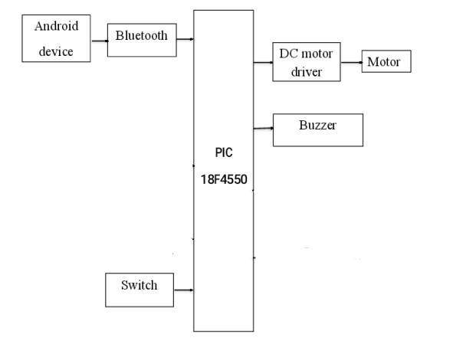

**List of Required Materials**

1. Vehicle Chassis with motors and wheels
2. 2 motors to control headboard and leg board (Need to experiment with various motors before finalizing)
3. Bluetooth module
4. Remaining parts would be 3D printed or requested when required (Major parts have been mentioned above)